Infrastructure as Code:

Lab Portfolio: Part 1

# Learning Outcomes:

This assignment focuses on bringing IaC concepts together in a business solution via a mini-network. Best practice is required throughout. A class period will be allocated to initial discussion on the assignment to enable team work in teasing out the problem(s) at hand. The assignment due date is as shown in Blackboard.

LO’s covered by this assignment are:

1. Engage in practitioner-based research to compose solutions to deployment pipeline efficiency issues
2. Conceptualise, research and critique techniques and technologies to automate processes and job lifecycles
3. Undertake an analysis of incomplete, incorrect or contradictory solutions to a problem and communicate in a professional manner an alternative approach underpinned by justifications informed by clearly articulated research.
4. Critical awareness of the importance of coding best practice in disseminating information to enhance teamwork.
5. Analyse the impact of scripted pipelines on enhancing team work in delivering software across a pipeline.
6. Devise a scripted solution for a software delivery pipeline including design, implementation and test phases.
7. Review and refactor scripts via peer-review retrospective and refinement meetings.

# Submission:

You are required to submit:

Do not zip the files!

1. All cloud formation files.
   1. 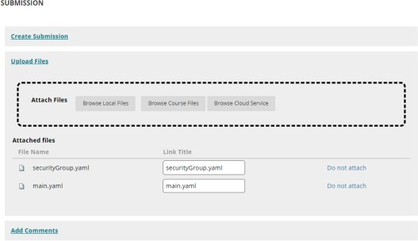Upload all yaml files in 1 submission. In the image below 2 files are shown in 1 submission. Zipped files will not be accepted.
2. A word/pdf document with:
   1. A link to your github repo with code to enable review of continuous updates to your files.
   2. A two page conclusion justifying your design choices.
   3. An appendix of images of your final system running in AWS.

# The Business Problem

A small company FridayHITT provide customised different HITT training every Friday with running routes local to your location. They have approached you to design a mini network for the online presence. They can see that the company will expand rapidly so they want the design to be extensible from the start. They know that applying good practices from the start will make this easier. Provide appropriate services and documentation to get them going.

Create a Cloud Formation Stack using the Application Composer. The purpose is to replicate the mini network.

* + - 1 private Subnet with an EC2 instance
    - 1 public subnet with an EC2 instance
    - Security Groups
    - Appropriate networking to enable communications but block any unnecessary communications.
      * Gateway
      * Routing tables
    - An availability zone
    - A virtual Private Cloud

One subnet is public facing whilst the other is private. Within each are security groups. Your EC2 instances (servers) should be tied to the appropriate groups. Make sure you have a jump_box to connect via ssh to the instances in the private subnet. Set up appropriate routing tables and gateways.

Consider how your solution would change if you expanded your network so it includes two availability zones. The jump box would have to be able to access instances within an availability zone should be able to connect to each other. This is not a feature we need to implement but it should be mentioned in the conclusions

To solve this problem you will need to carry out a number of steps. Some hints on relevant steps are given in the next page.

# Planning

Use the following points to help you plan the assignment before commencing.

1. Create a suitable set of IP addresses for your network. Remember that your routing tables will rely on this as will your security group. Fill in the table for yourself for each part of the network. Remember that we want to deny by default and only allow whatever is essential to each subnet and security group.

|  |  |  |  |  |
| --- | --- | --- | --- | --- |
| Type | Protocol | Port | Source | Allow/Deny |
| SSH | TCP | 22 | (CIDR IP Address  here) | Allow (or deny depending on  where this rule is used! |
|  |  |  |  |  |

1. Create routing tables to help with allowing communications from one subnet to another. The VPC address is a top-level address so allow sufficient room for all your ip addresses. E.g. 10.1.2.0/16 or /24 depending on your needs. When working out the number of addresses you need don’t forget to count the internet gateway.
2. An elastic ip address can be used to enable servers to be seen by the outside network in a production environment. **However, as they cost money to run, you can simply use internal addresses here if you prefer. This will require a change to the design of your architecture.**
3. Link the components in your stack appropriately to make a mini-network.
   1. Test to ensure it works
   2. Screen grab the results for the written lab report
   3. Screen grab the solution in Application composer and the list of resources.
4. Tidy the file to make it reusable:
   1. Break it up
   2. Use parameters and mapping
5. In the conclusions discuss how you applied or considered:
   1. Best practice to tidy up the code
   2. Security
   3. Reliability and high availability (consider spreading across availability zones) are a consideration. Give one example of each element to demonstrate their importance.

Plan carefully before you begin to code! What do you need? How do they connect? How do you keep it secure? Can you make the code clean and reusable?

Time will be given in class for group discussion to aid progress but an individual solution and individual submissions are required. The discussion in groups will aid the experience of team work on solutions but without individual development.